Amanda J. (Nicholson) Strausbaugh-Wolfe
April 17, 1880 – January 17, 1973

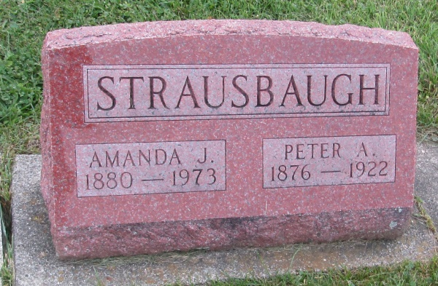

Amanda Strausbaugh in the Web: Indiana, U.S., Marion Public Library Marriage Index, 1831-2008
Name: Amanda Strausbaugh
Gender: Female
Marriage Date: 16 Feb 1952
Marriage Place: Grant, Indiana, USA
Spouse: Erna Wolfe
URL: http://www.marion.lib.in.us/request-genealogy-records-2/
*****
Indiana, U.S., Death Certificates, 1899-2011
Name: Amanda Jane Wolfe
[Amanda Jane Nicholson]
Gender: Female
Race: White
Age: 92
Marital status: Married
Birth Date: 17 Apr 1880
Birth Place: Indiana
Death Date: 17 Jan 1973
Death Place: Marion, Grant, Indiana, USA
Father: Nicholson
Mother: Alvira Ann Platt
Spouse: Erna B Wolfe
Informant: Erna B. Wolfe; husband; Marion, Indiana
Burial: January 20, 1973; Prospect Cemetery; Uniondale, Indiana

