Meredith E. Sparks
October 25, 1909 – August 28, 1994

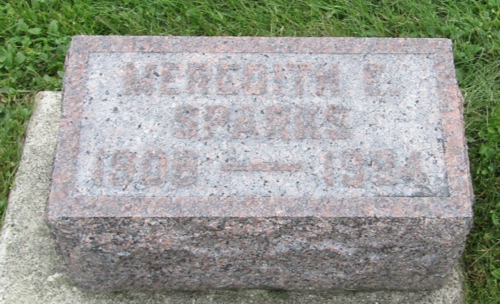

Meredith E Sparks
in the Florida, U.S., Death Index, 1877-1998
Name: Meredith E Sparks
Race: White
Age at Death: 84
Birth Date: 25 Oct 1909
Death Date: 28 Aug 1994
Death Place: Pasco, Florida, United States

