Della M. (Wolfcale) Sparks
January 23, 1881 – March 15, 1966

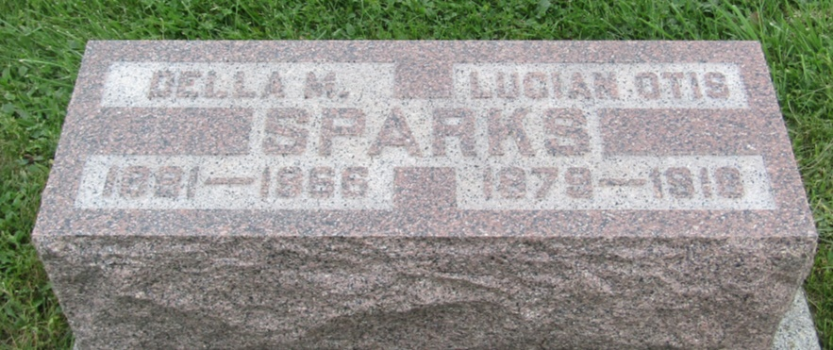

Services for Della M Sparks, 85, of 2201 St Joe Blvd, will be at 1 pm Thursday in the Prospect Methodist Church, near Ossian, Rev Walter Burcham officiating. Burial will be in the church cemetery.
Mrs. Sparks died at 1:15 am yesterday in Parkview Memorial Hospital where she had been a patient since Dec 30.
She was a native of Wells County and had resided here 20 years.
Surviving are three sons, Hadley, Fort Wayne, Maynard W, Etna Green and Meredith E, Philadelphia; two daughters, Mrs. Adolph Bradtmueller, Fort Wayne and Mrs. Merrill Barry, Cardington, Ohio; seven grandchildren and 18 great-grandchildren.
Friends may call at the DO McComb Sons Funeral Home after 2 pm today and at the church from 11 am Thursday until time of services.

Journal Gazette, Allen County, Indiana
March 16, 1966

*****

Indiana, U.S., Death Certificates, 1899-2011
Name: Della M Sparks
[Della M Wolfcale]
Gender: Female
Race: Wh
Age: 85
Marital status: Widowed
Birth Date: 23 Jan 1881
Birth Place: Indiana
Death Date: 15 Mar 1966
Death Place: Fort Wayne, Allen, Indiana, USA
Father: James Wolfcale
Mother: Mary A Sowle
Informant: Hadley Sparks; son; Fort Wayne, Indiana
Burial: March 17, 1966; Prospect Cemetery; Ossian, Indiana

