Kora I. Sowle
October 9, 1870 – December 23, 1874

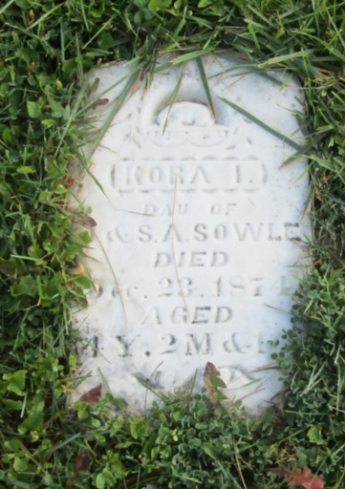

No further information found at this time

