John Sowle
June 29, 1886 – September 9, 1886

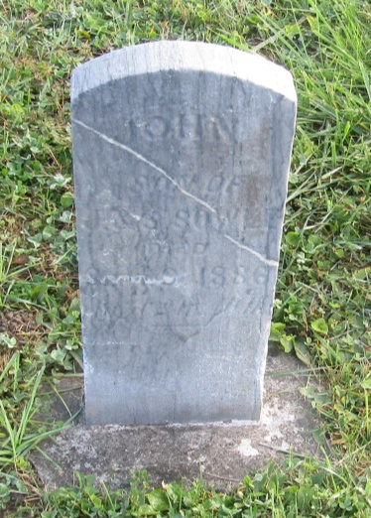

No further information found at this time

