Zepha P. (Longshore) Smith
May 24, 1883 – May 25, 1972

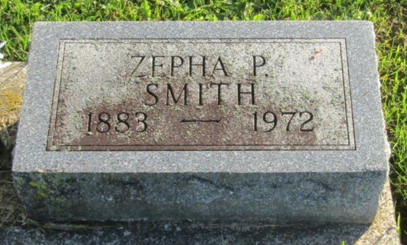

Mrs. Zepha P. Smith, 89, of 219 North Marion Street died Thursday in Wells Community Hospital. Born May 24, 1883 in Wells County, she was a daughter of Ira K. and Frances McDermot Longshore. Her marriage to Frank S. Smith, who died in 1926, took place in Wells County on December 24, 1903.
Surviving is a daughter, Mrs. John (Leita) Osborn of Markle, eight grandchildren and 16 great-grandchildren.
Elzey Funeral Home in Ossian is in charge with services to be held there Sunday. Burial will be in Prospect Cemetery.

Bluffton News-Banner, Wells County, Indiana
May 25, 1972

*****
Indiana, U.S., Death Certificates, 1899-2011
Name: Zepha P Smith
[Zepha P Longshore]
Gender: Female
Race: White
Age: 89
Marital status: Widowed
Birth Date: 24 May 1883
Birth Place: Indiana
Death Date: 25 May 1972
Death Place: Bluffton, Wells, Indiana, USA
Father: Ira K Longshore
Mother: Francis McDermot
Informant: Mrs. John Osborn; daughter; Markle, Indiana
Burial: May 28, 1972; Prospect Cemetery; Markle, Indiana

