Frank S. Smith
May 10, 1881 – October 6, 1926

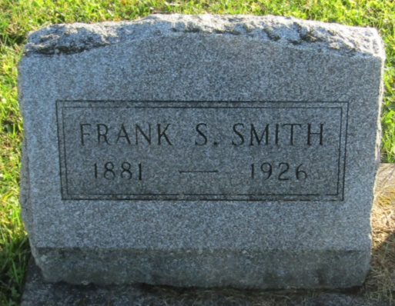

Frank Smith
in the Indiana, U.S., Death Certificates, 1899-2011
Name: Frank Smith
Gender: Male
Race: White
Age: 45
Marital status: Married
Birth Date: 10 May 1881
Birth Place: Indiana
Death Date: 6 Oct 1926
Death Place: Union, Wells, Indiana, USA
Father: Peter Smith
Mother: Mary Thomas
Spouse: Zepha
Informant: Zepha Smith; Ossian, Indiana
Burial: October 8, 1926; Prospect Cemetery

