William H. Shady
September 8, 1858 – May 14, 1937

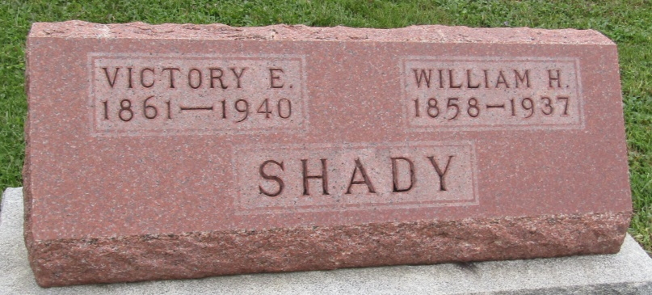

Wm H Shady
in the Indiana, U.S., Death Certificates, 1899-2011
Name: Wm H Shady
Gender: Male
Race: White
Age: 78
Marital status: Married
Birth Date: 8 Sep 1858
Birth Place: Wells Co Indiana
Death Date: 14 May 1937
Death Place: Ft Wayne, Allen, Indiana, USA
Father: Samuel Shady
Mother: Jane Mills
Informant: Victory Shady; Fort Wayne, Indiana
Burial: May 16, 1937; Prospect Cemetery

