Vera Maxine (Mounsey) Scott
March 22, 1930 – October 2, 2020

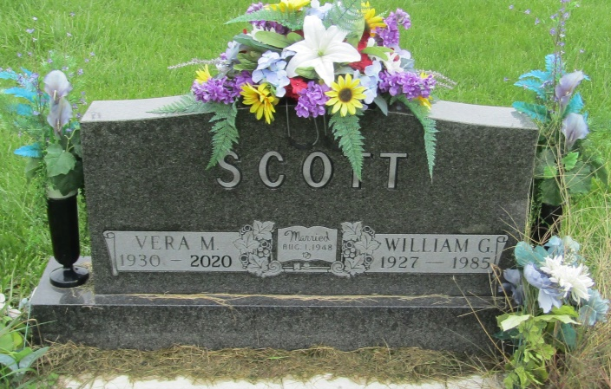

Vera Maxine Mounsey passed away on October 2, 2020 (Age 90) at Heritage Point. She was born on March 22, 1930 to Victor and Grace (Lockwood) Mounsey.
She had 5 brothers (Dean, Max, Kay, Brooks, and Bill) and 4 sisters (Marcella, Mona Jean, Phyllis, and Karen). All ten children and their parents were busy on the large farm in Chester Township, Wells County.
Vera was active at home as well as at Chester Center High School. She was in the play, “Calamity Kids”, playing the part of Loraine Ludlow during her senior year. During that year she was on the Pow Wow Staff and helped publish the monthly school paper. She was in the Glee Club, Booster, Sunshine Society and active in her senior class. Her nickname of “Verdie” remained with her throughout her whole life. Her yearbook listed that her ambition was to be a secretary. She was able to attend yearly reunions of her senior class nearly every year and enjoyed her communications with her friends.
During her high school years, she met the love of her life, Billy (William) Graham Scott (1927-1985). Her high school yearbook “Senior Prophecy” listed that she had a career change, wishing now “planned to be a secretary but after a month’s consideration, decided she would rather let Bill be boss and sit on his knee… with color scheme of Lancaster green and Chester gold”.
William G. Scott and Vera Mounsey married at South Liberty Church in Liberty Township, Wells County, on August 1, 1948. They had 5 children- Linda (Brian) Eltzroth, Gloria (James) Huffman, Ted Scott, Barry (Shelly) Scott, and Brent (Jenessa) Scott. Ten grandchildren: Brent Eltzroth, Deidre Eltzroth, Becky Boyd, Nathan Huffman, Michelle Barker, Tyler Scott, Meghan Scott, Logan Scott, Thea Scott, and Trevin Scott. They were also blessed with 16 great-grandchildren: Mallory, Callie, Kennedy, Graham, Alice, Emma, Lily, Geno, Aiden, Faith, Oliver, Isaac, Evan, Hudson, Lincoln, and Brooklyn.
Vera, Bill, and most of the Scott and Mounsey families loved to play cards. She was competitive and active even in rounds of double and triple solitaire. A person could hear the cards slap the table two rooms away. Vera and Bill loved to travel. Bill won trips through insurance sales to Biloxi and to be with family in many states, including Virginia. She traveled by bus (Markle 55+) with Mona Jean to Gatlinburg, Pigeon Forge, Branson, and theatre performances. Vera also went on Cruise Royal Caribbean with her brothers, sisters, and their spouses during February 12-19, 2000. She was excited any time she could be with family.
Unfortunately, Bill passed away on November 21, 1985. While missing Bill, this loss brought Vera, Barry and Brent very close. The three would have adventures when Vera worked at Wells Community Hospital. She would make sack lunches for them before leaving for work. Unbeknownst to her, they would get up, find their lunches, and often eat them prior to 9am. That summer, the three of them went to Disney World in Orlando with Linda and her family. Phyllis, Karen, Mona Jean and Vera enjoyed short trips together also.
Vera worked at Wells Community Hospital for 19 years, starting in the front office and then filing insurance claims. After her retirement in July of 1995, she worked at Duane’s Sweeper Shoppe and volunteered at the Bargain Hut in Bluffton. This was fun for her as she made many friends and was often with her sister, Mona Jean. Vera loved her involvement at First Church of Christ in Bluffton and she had many friends in the Circle.
Vera moved to Heritage Point in Warren on August 6, 2014. She had an apartment in Innis and was very proud of it and welcomed all to visit. Later, she moved to a bedroom suite in 1 B. Still, her room decorations were very important to her as she welcomed guests. Vera loved the nursing and care staff at Heritage Point and looked at them as members of her family. She was constantly asking to help them by folding wash cloths, etc. She spoke constantly about the Activities Program – music concerts, Bingo games, golf-kart rides, and field trips to the zoo, etc. She felt like she was a princess at a resort.
Vera always had one of her biggest smiles when she was holding a baby or child, sitting close to them, or having her arm around them. There was a strong competition whenever a newborn family visited as to who was going to hold the baby first.
Upon any visit, she could always cook a meal for guests with no notice. The family loved the Sunday dinners together at her house with cards, Monopoly and many other games. Her greatest pleasures were times spent with family and friends. She was always eager for one more time with them and often asked when they were coming back, as soon as they arrived to see her.
Vera was predeceased by loving family members Bill (William) Graham Scott in 1985, son Ted Scott in 2014, son-in-law Jim Huffman in 2014, grandson Jamie Huffman in 1977, and her parents Victor Mounsey in 1984 and Grace Mounsey in 1999. Some of her siblings and their spouses have also passed on.
Arrangements are being handled by Glancy- H. Brown & Son Funeral Home in Warren, IN. Visitation hours will be on Thursday, October 8, 2020 from 2pm until 7pm. A funeral service will follow at 7pm with Pastor Dick Case officiating. Visitation and Service will be held at Glancy H. Brown & Son Funeral Home 203 N Matilda St. Warren, IN 46792.

Glancy Funeral Homes, Huntington County, Indiana
October 3, 2020

