Glendora Scott
February 12, 1885 – June 9, 1894

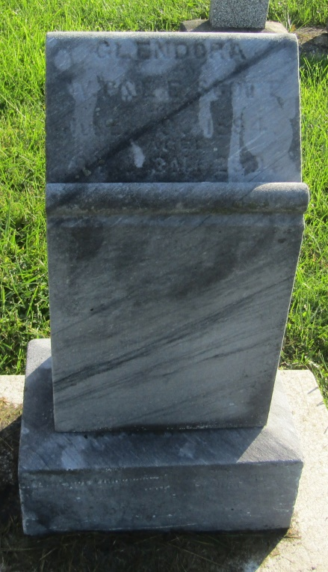

No further information found at this time

