Deborah (McCorkle) Scott
May 24, 1804 – July 16, 1870

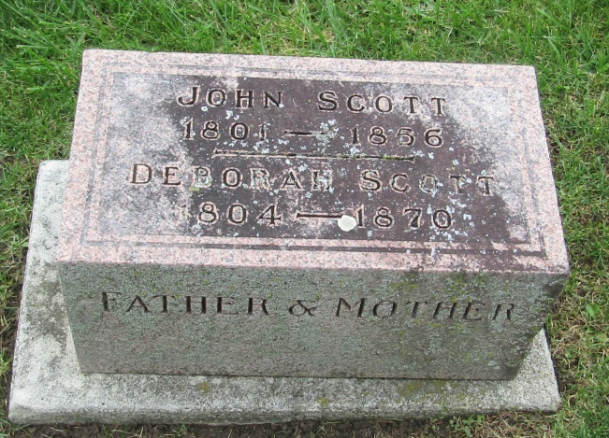

Deborah McCorkle from tree K Woodford Family Tree
Birth 24 May 1804 Philadelphia, Philadelphia, Pennsylvania, USA
Marriage 21 Feb 1825 Trumbull, Ashtabula, Ohio, USA
Residence 1870 Wells, Indiana, USA
Death 16 Jul 1870 Wells, Indiana, USA
Father John McCorkle (1774-1833)
Mother Isabella Muir Montgomery (1778-1821)
Spouse John Scott (1804-1856)

