Alva C. Scott
August 26, 1859 – November 5, 1859

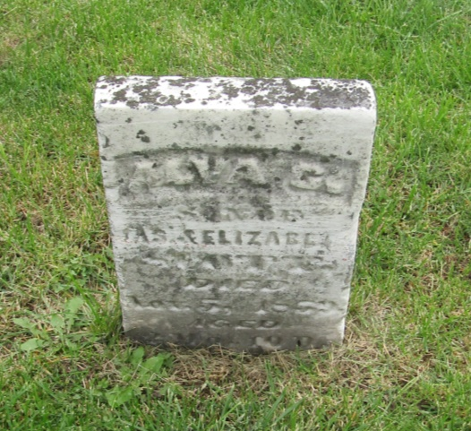

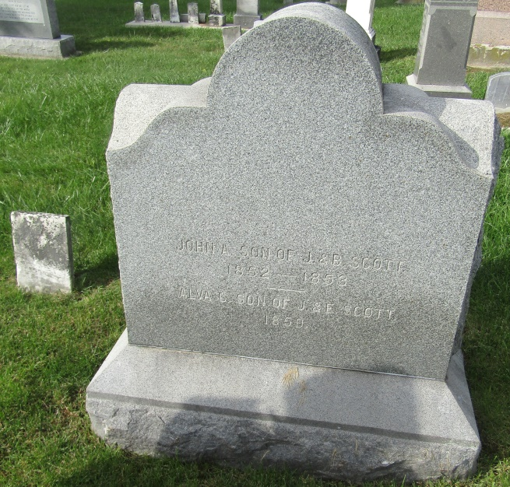

Alva C. Scott from tree 1850 Scotts of Marion County, IN
Birth 26 Aug 1859 Wells, Indiana, USA
Death 5 Nov 1859 Wells, Indiana, USA
Father James Scott (1825-1906)
Mother Elizabeth Scott (1835-1911)

