Infant son Schoeff
November 16, 1920 – November 16, 1920

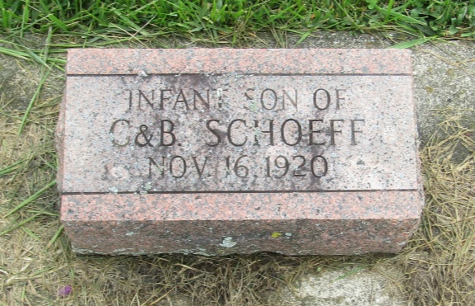

No further information found at this time

