Eugene Schoeff
January 6, 1925 – October 15, 1925

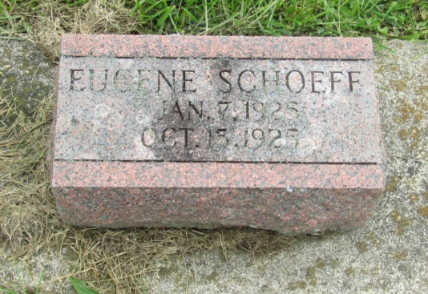

Eugene Schoeff
in the Indiana, U.S., Birth Certificates, 1907-1944
Name: Eugene Schoeff
Gender: Male
Birth Date: 6 Jan 1925
Birth Place: Jefferson, Wells, Indiana, USA
Father: Charles A. Schoeff
Mother: Bessie Newhard; 8th child; 7 are living
Certificate Number: 5357
Roll Number: 40474_357754
Volume Range: 11 - 15
*****

Indiana, U.S., Death Certificates, 1899-2011
Name: Eugene Schoeff
Gender: Male
Race: White
Age: 9 months, 9 days
Birth Date: 6 Jan 1925
Birth Place: Indiana
Death Date: 15 Oct 1925
Death Place: Wells, Indiana, USA
Father: Charles Schoeff
Mother: Bertha Newhard
Informant: Charles Schoeff; Uniondale, Indiana
Burial: October 18, 1925; Prospect Cemetery

