Keith Myron Schilling
June 13, 1926 – October 2, 1995

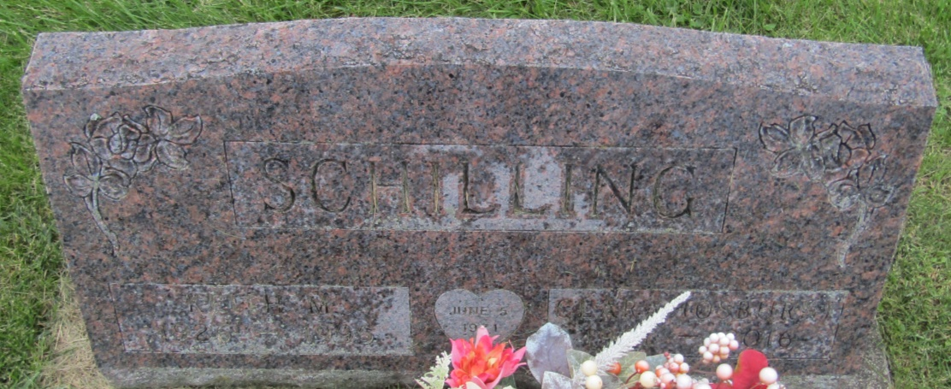

Keith Myron Schilling
in the Indiana, U.S., Death Certificates, 1899-2011
Name: Keith Myron Schilling
Gender: Male
Race: White
Age: 69
Marital status: Married
Birth Date: 13 Jun 1926
Birth Place: Wabash County In
Death Date: 2 Oct 1995
Death Place: Bluffton, Wells, Indiana, USA
Father: Clarence Schilling
Mother: Laura Schrock
Spouse: Clara J Osburn
Informant: Clara Schilling; wife; Pennville, Indiana
Burial: October 6, 1995; Prospect Cemetery; Wells County, Indiana

