John H. Scherrer
August 11, 1878 – December 3, 1951

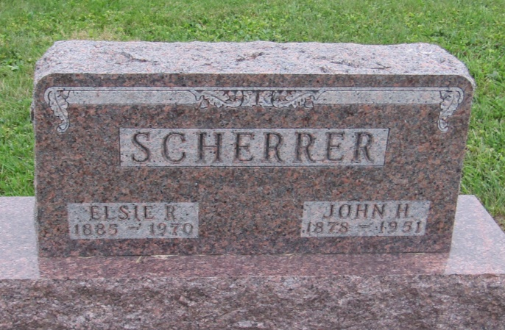

John H Scherrer
in the Indiana, U.S., Death Certificates, 1899-2011
Name: John H Scherrer
Gender: Male
Race: White
Age: 73
Marital status: Married
Birth Date: 11 Aug 1878
Birth Place: Allen County Ind
Death Date: 3 Dec 1951
Death Place: Rural, Wells, Indiana, USA
Father: Henry Scherrer
Mother: Elizabeth Rhodes
Informant: Mrs. John Scherrer; Ossian, Indiana
Burial: December 5, 1951; Prospect Cemetery; Ossian, Indiana

