M. Lucille (Bland) Richhart
May 11, 1909 – October 26, 1976

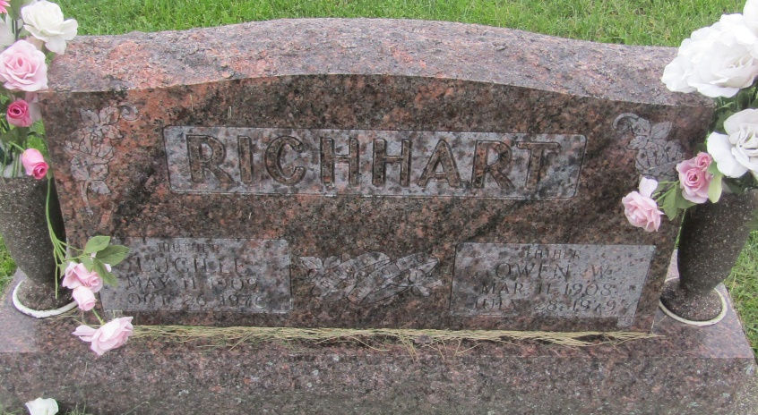
M Lucille Richhart
in the Indiana, U.S., Death Certificates, 1899-2011
Name: M Lucille Richhart
[M Lucille Bland]
Gender: Female
Race: White
Age: 67
Marital status: Married
Birth Date: 11 May 1909
Birth Place: Michigan
Death Date: 26 Oct 1976
Death Place: Fort Wayne, Allen, Indiana, USA
Father: Charles Bland
Mother: Bertha Johnson
Spouse: Owen Richhart
Informant: Owen Richhart; husband; New Haven, Indiana
Removal: October 28, 1976; Ind. Univ. Med. Center; Indianapolis, Ind.

