Lillian (Milligan) Reddin
August 19, 1880 – June 9, 1950

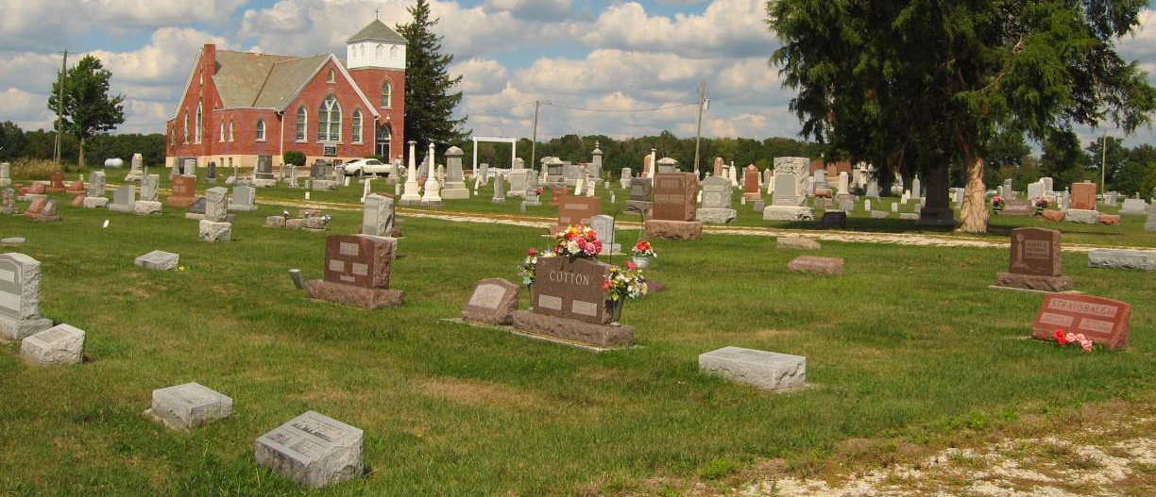
Photo by Tombstoner & Family

Mrs. Lillian Reddin, 69, former resident of this city, Markle and the vicinity of Zanesville, died at 8 p.m. Friday at the home of a son, Henry E. Reddin, four and one-half miles northeast of Roanoke where she had been for four weeks. She moved there from a home three miles east of Zanesville.
Mrs. Reddin was born August 19, 1880, to Charles and Mary Fosnaugh Milligan and was married to Harrison H. Reddin, September 9, 1897. He died April 1, this year.
Surviving are two sons, Henry, at whose home she died, and Paul, Espinola, N. M.; two daughters, Mrs. Frank Ford, Fort Wayne, and Mrs. Benjamin Ross, Markle; three sisters, Mrs. Alva Smith, Maples, Ind.; Mrs. Lee Young, near Angola, and Mrs. John Aoehler, Ray, Ind., 16 grandchildren and one great-grandchild.
Mrs. Reddin was a member of the Markle Church of Christ.
The body was taken to the Elzey & Sons Mortuary at Ossian where friends may call after 2 p.m. Sunday. It will lie in the Markle Church of Christ from 1 p.m. Monday until the hour of the funeral at 2 p.m. with the Rev. Richard C. Burton officiating. Interment will be in Prospect Cemetery west of Ossian.

Herald-Press, Huntington County, Indiana
June 11, 1950

