Infant Reddin
June 23, 1898 – June 23, 1898

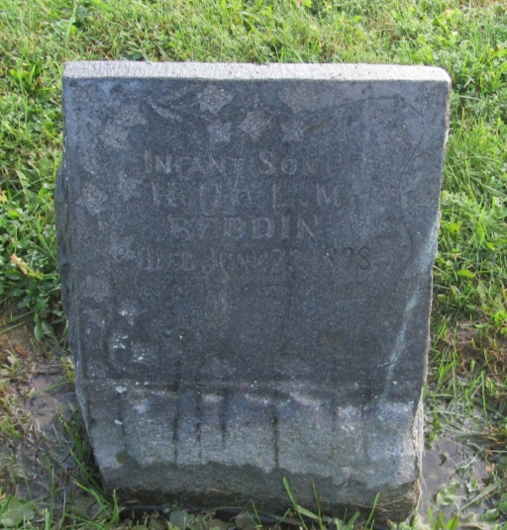

No further information found at this time

