Harrison H. Reddin
November 8, 1872 – April 12, 1950

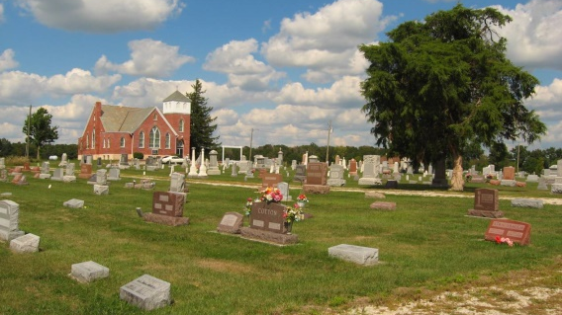
Photo by Tombstoner & Family

Harrison H. Reddin, 77, former resident of near Huntington and the community of Markle, died at 5:45p.m. Wednesday at his home three milles east of Zanesville after an illness of a year. Mr. Reddin was a member of the Markle Church of Christ and was employed for 22 years by various railroad companies.
Surviving are the widow, Lillian; two sons, Paul Reddin, Espinola, N.M. and Henry Reddin, Roanoke; two daughters, Mrs. Frank Ford, Fort Wayne, and Mrs. Benjamin Ross, Markle; two sisters, Mrs. Jason Zion, Waynedale, and Mrs. Vollie McKim, Huntington; 16 grandchildren and one great-grandchild.
The body was removed to the Elzey & Son funeral home at Ossian where friends may call after 2 p.n.. Friday. The body will be removed to the Markle Church of Christ at 1 p.m. Saturday to lie until 2 p.m. when services will be conducted by the Rev. Richard C. Burton. Burial will be in the Prospect cemetery, four miles west of Ossian.

Herald-Press, Huntington, Indiana
April 13, 1950
*****

Indiana, Death Certificates, 1899-2011

Name: Harrison H Reddin
Gender: Male
Race: White
Age: 77
Marital status: Married
Birth Date: 8 Nov 1872
Birth Place: Indiana
Death Date: 12 Apr 1950
Death Place: Rural, Wells, Indiana, USA
Father: Albert Reddin
Mother: Mary Nickolson
Informant: Henry E. Reddin, Roanoke, Ind.
Burial: April 15, 1950 Prospect

