Charles H. Reddin
January 30, 1939 – January 25, 2010

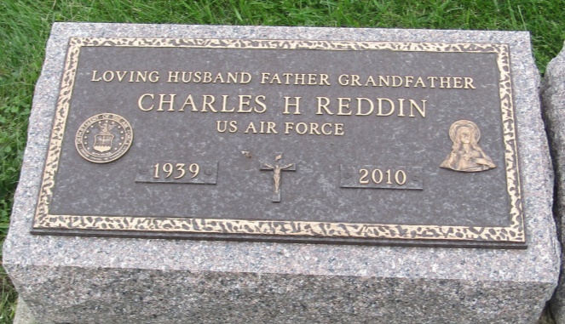

Charles Reddin ended his earthly journey Monday, Jan. 25, 2010, 4:15 a.m. His final days were spent in his home, surrounded by his wife, daughters, family and friends. He waged a brave battle with cancer in the same manner he lived his life - with jokes, smiles, love and prayer.
He was a veteran of the United States Air Force, a graduate of Indiana University, and served two terms as a New Haven City Councilman, District 3. He also served on the planning commission and the economic development commission for that city. By profession, he was a manufacturing engineer, employed by International Harvester, Fort Wayne, AM General (LTV), South Bend, and Excel Industries, Elkhart. He was an active parishioner of Our Lady of Good Hope Catholic Church for 10 years, and a member of the Knights of Columbus, Council No 12417.
He loved children and coached CYO football, and girls softball, was a Girl Scout Dad, and YWCA Indiana Princess Chief. He loved playing golf, bowling, reading, and euchre. Most of all, he deeply loved his family, and everyone he met.
He is survived by his loving wife of 50 years, Judy (Martin); three daughters, Molly Alexander of Fort Wayne, Kate (Rob) Haney of New Haven and Sara (Eric) Knight of Goshen; foster daughter, Kathy (Randy) Riddle of Indianapolis; son-in-law, Mark Alexander of Indianapolis; nine grandchildren; six great-grandchildren; sister, Patty (Walter) Wilburn of Port Charlotte, Fla.; great aunt, Rachel Ross of Fort Wayne; and chosen brothers and sister, Mike Miller of Fort Wayne, Mark Miller of LaOtto and Pat Fox of New Haven. He was preceded in death by his parents, The Rev. Charley A. and Neola Reddin.
Mass of Christian Burial is 2 p.m. Friday at St. John The Baptist Catholic Church, 943 Power St., New Haven, with visitation one hour prior. Visitation also from 2 to 4 and 6 to 8 p.m. Thursday at Hockemeyer & Miller Funeral Home, 6131 St. Joe Road; Private burial in Prospect Cemetery, Ossian.
Preferred memorials to St. Mary's Soup Kitchen or The Women's Care Center of Fort Wayne.

Fort Wayne Newspapers, Allen County, Indiana
January 27, 2010

*****
Indiana, U.S., Death Certificates, 1899-2011
Name: Charles H. Reddin
[Charles H. N/A]
Gender: Male
Race: White
Age: 70
Marital status: Married
Birth Date: 30 Jan 1939
Birth Place: Fort Wayne, IN
Death Date: 25 Jan 2010
Death Place: Fort Wayne, Allen, Indiana, USA
Father: Charley A. Reddin
Mother: Neola G. Miller
Spouse: Judith A. Martin
Informant: Judith A. Redding; wife; Fort Wayne, Indiana
Burial: Prospect Cemetery; Ossian, Indiana

