Phebe (Hudson) Quackenbush
1820 - 1864

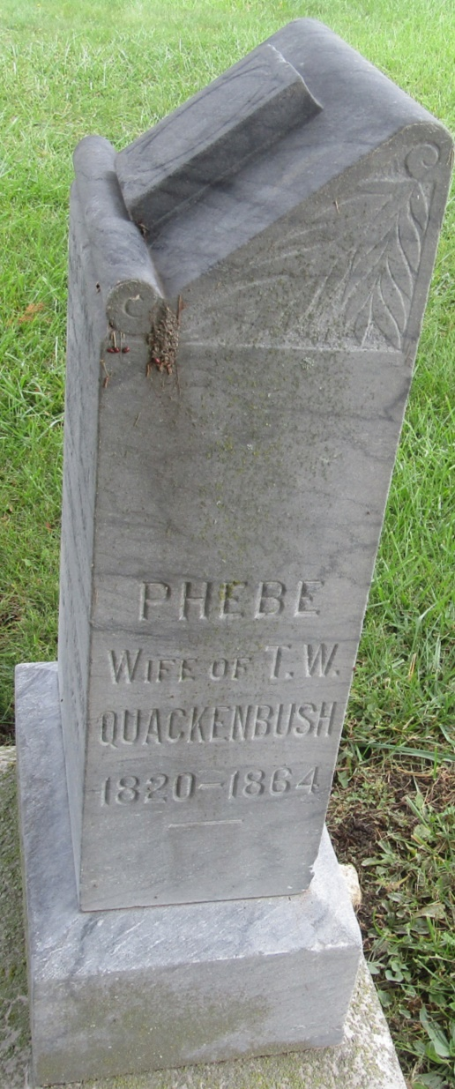

No further information found at this time

