Harriet (Templeton) Prough
August 2, 1854 – January 6, 1906

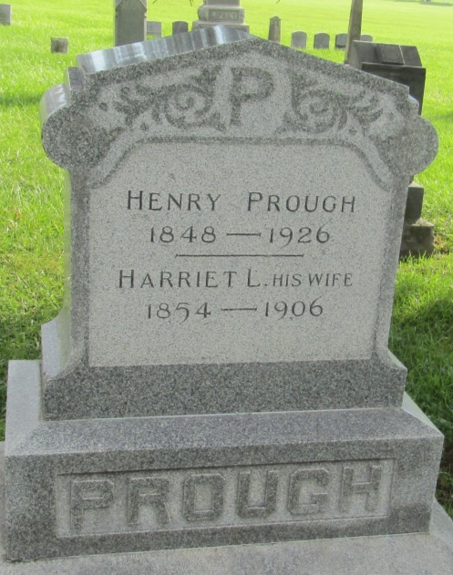

Mrs. Harriet Prough, wife of Henry Prough, four miles southwest of Ossian, is dead as the result of her suicidal attempt Monday afternoon, when she slashed her throat with a butcher knife. It is presumed the woman was demented.

Fort Wayne Weekly Sentinel; Allen County, Indiana
Wednesday, January 17, 1906
*****
WOMAN SLASHES HER THROAT
(Special to the Journals)

Bluffton, Ind., Jan. 10 – Mrs. Harriet Prough, wife of Henry Prough, committed suicide at her home in Jefferson Township this morning by slashing her throat with a butcher knife. For some time, she had been suffering with some kind of mental malady and had been under close guard for a number of weeks. This morning she arose about 3 o'clock and before any of her guards could stop her, she went to the kitchen and slashed both sides of her throat. Doctors were called, but could do little for her, and she died at 3 o'clock this afternoon.

Logansport Journal; Logansport, Indiana
January 11, 1906
*****
Indiana, U.S., Death Certificates, 1899-2011
Name: Harriet Prough
[Harriet Templeton]
Gender: Female
Race: White
Age: 51
Marital status: Married
Birth Date: 2 Nov 1854
Birth Place: Mills Couty Ind
Death Date: 9 Jan 1906; suicide
Death Place: Ossian, Wells, Indiana, USA
Father: Robert Templeton
Mother: Hu??nly
Spouse: Henry Prough
Informant: Henry Prough; Ossian, Indiana
Burial: January 11, 1906; Prospect Cemetery

