Jacob W. Osborn
January 25, 1857 – June 24, 1923

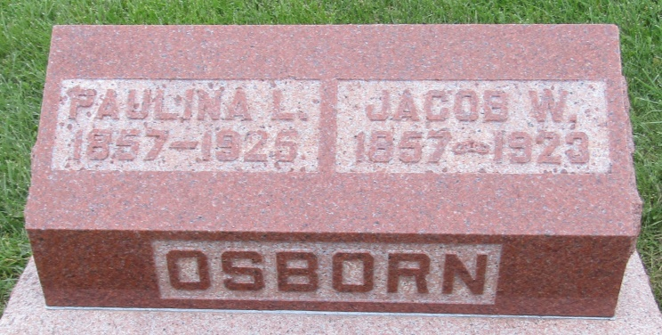

The year 1857 was the birth year of Jacob Osborn who is the largest contractor living in Ossian. He is the son of Levi and Catherine Osborn, pioneer settlers of Union Township. These people of good English stock moved in from Eastern Ohio when the broad cultivated acres, upon which they now reside, were massed and covered with heavy timber and thick underbrush. Being people of zeal and pluck, they soon made a showing upon the forests, and became by their efforts, well-to-do, respected farmers.
Jacob Osborn spent his early life in Union Township, getting his education in the common schools, and assisting upon his father's farm. He was, however, possessed of a natural attitude for carpentering -- an attitude which almost amounted to genius, for he mastered the secrets of the trade, and worked his way up to the top notch in the art of building by his own untiring efforts. It is truly a remarkable fact that skilled as he is, Mr. Osborn never served an apprenticeship, having always been his own master and instructor.
In 1891 he moved from a farm upon which he had been working, purchased property in Ossian, and launched himself out on a then to him, almost untried sea. Starting single handed with such knowledge as came from pure natural ability he made an immediate success, and his work gained forthwith. Soon he was taking contracts and was obliged to get assistance. For the last year he has been running a gang of hands, furnishing four or five men with steady employment almost the year around, at intervals enlarging upon his present force.
As a framer Mr. Osborn has few equals in this part of the country. He does his own designing, and all architectural work which comes in his line of business. He has labor at all times, and is one of our busiest citizens.

20th Century Souvenir Edition of the Ossian News
January 1, 1900

*****
Indiana, U.S., Death Certificates, 1899-2011
Name: Jacob W. Osborn
Gender: Male
Race: White
Age: 66
Marital status: Married
Birth Date: 25 Jan 1857
Birth Place: Indiana
Death Date: 24 Jun 1923
Death Place: Ossian, Wells, Indiana, USA
Father: Levi Osborn
Mother: Catharine Ashburn
Spouse: Pauline L.
Informant: Mrs. Jacob Osborn; Ossian, Indiana
Burial: June 26, 1923; Prospect Cemetery; Jefferson Township

