Ruth Orr
November 4, 1901 – February 28, 1910

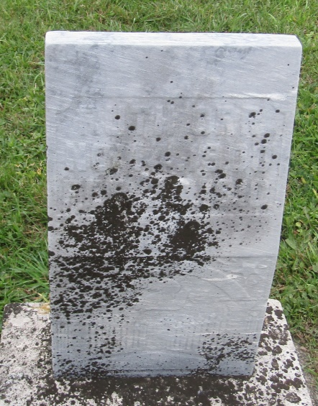

Ruth Orr
in the Indiana, U.S., Death Certificates, 1899-2011
Name: Ruth Orr
Gender: Female
Race: White
Age: 9 years, 3 months, 24 days
Marital status: Single
Birth Date: 4 Nov 1901
Birth Place: Indiano
Death Date: 28 Feb 1910
Death Place: Union, Wells, Indiana, USA
Father: J. Orr
Mother: Martha Double
Informant: J. Orr; Uniondale, Indiana
Burial: March 2, 1910; Prospect Cemetery

