Argus Luster Ormsby
February 18, 1894 – November 27, 1967

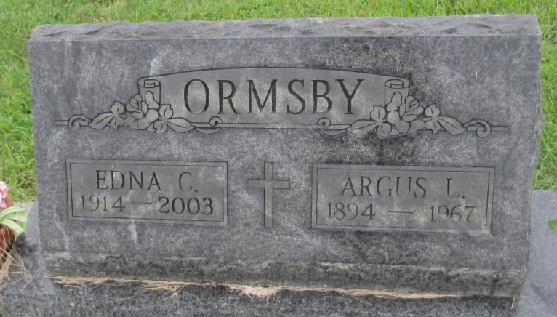

Argus Luster Ormsby
in the Indiana, U.S., Death Certificates, 1899-2011
Name: Argus Luster Ormsby
Gender: Male
Race: Wh
Age: 73
Marital status: Married
Birth Date: 18 Feb 1894
Birth Place: Indiana
Death Date: 27 Nov 1967
Death Place: Fort Wayne, Allen, Indiana, USA
Father: Alonzo Ormsby
Mother: Mary Archbold
Informant: Catherine Wilson; daughter; Fort Wayne, Indiana
Burial: November 30, 1967; Prospect Cemetery; Ossian, Indiana

