Oscar Orwell Newhard
October 29, 1871 – November 8, 1914

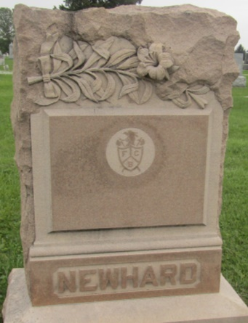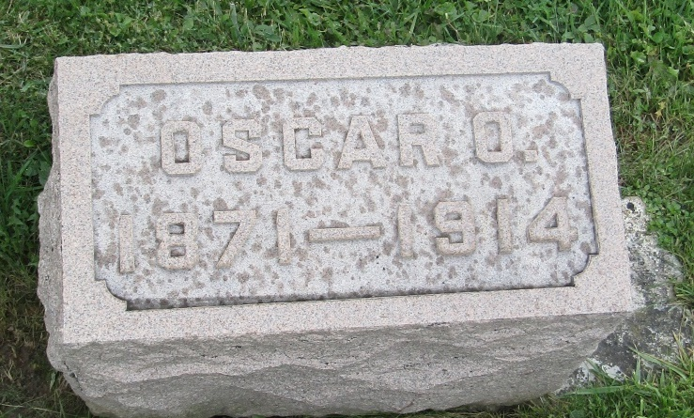

Oscar Orwell Newhard
in the Indiana, U.S., Death Certificates, 1899-2011
Name: Oscar Orwell Newhard
Gender: Male
Race: White
Age: 43
Marital status: Married
Birth Date: 29 Oct 1871
Birth Place: Wells County, Ind
Death Date: 8 Nov 1914
Death Place: Uniondale, Wees, Indiana, USA
Father: W. J. Newhard
Mother: Mary Ashburn
Spouse: Kathryn Belle
Informant: Kathryn B. Newhard; Uniondale, Indiana
Burial: November 12, 1914; Prospect Cemetery

