Kathrine (Gingrich) Newhard-Miller
November 4, 1877 – July 20, 1950

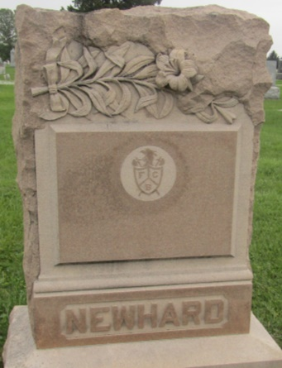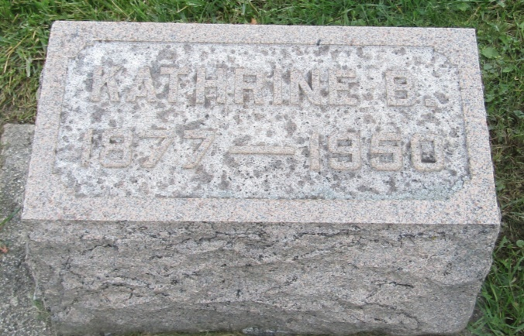

Kathrine Miller
in the Indiana, U.S., Death Certificates, 1899-2011
Name: Kathrine Miller
[Kathrine Gingrich]
Gender: Female
Race: White
Age: 72
Marital status: Widowed
Birth Date: 4 Nov 1877
Birth Place: Indiana
Death Date: 20 Jul 1950
Death Place: Bluffton, Wells, Indiana, USA
Father: John Calvin Gingrich
Mother: Louise Cassell
Informant: Mrs. Fred Humphrey
Burial: July 22, 1950; Prospect Cemetery; Union Township

