Infant daughter Newhard
December 26, 1905 – December 26, 1905

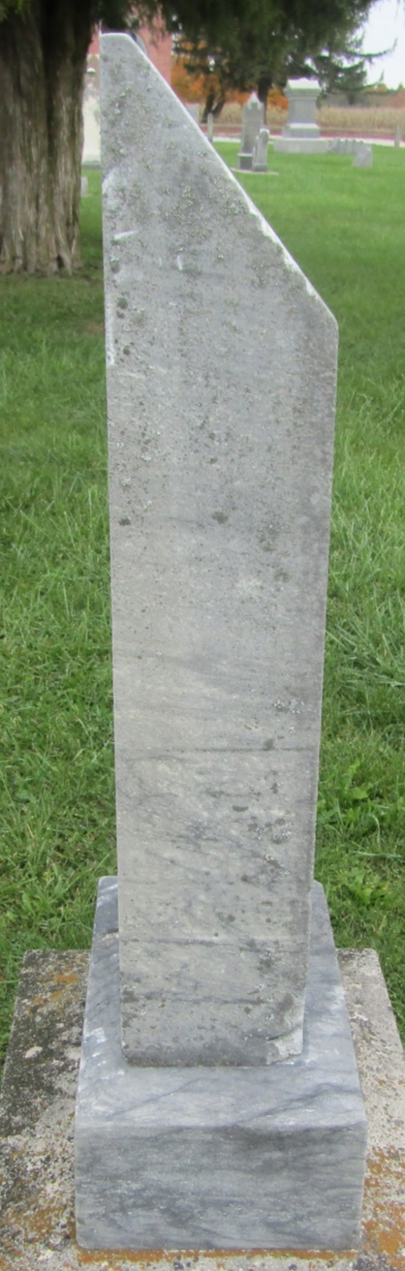

Infant Newhard
in the Indiana, U.S., Death Certificates, 1899-2011
Name: Infant Newhard
Gender: Female
Race: White
Age: 0
Marital status: Single
Birth Date: 26 Dec 1905
Birth Place: Adams Co
Death Date: 26 Dec 1905; stillbirth
Death Place: Adams, Indiana, USA
Father: Chas Newhard; born Wells County
Mother: Maud; born Wells County
Informant: Chas Newhard; Preble Township
Burial: December 27, 1905; Can't read cemetery

