Emma J. (Alger) Newhard
March 23, 1867 – September 13, 1935

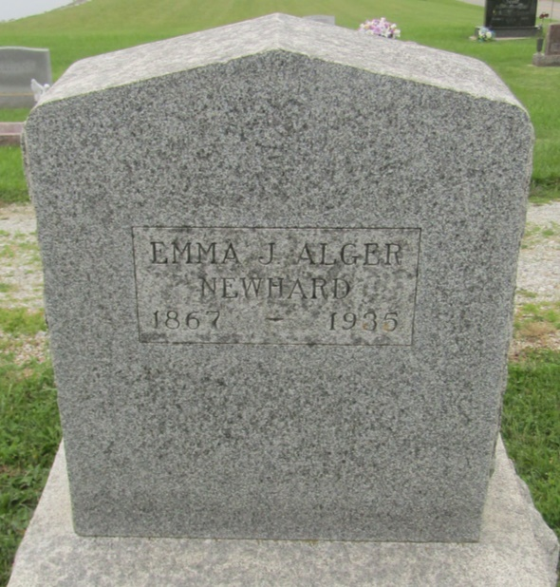

Emma J Newhard
in the Indiana, U.S., Death Certificates, 1899-2011
Name: Emma J Newhard
[Emma J Alger]
Gender: Female
Race: White
Age: 68
Marital status: Married
Birth Date: 23 Mar 1867
Birth Place: Virginia
Death Date: 13 Sep 1935
Death Place: Bluffton, Wells, Indiana, USA
Father: Harvey Alger
Mother: Mary Miller
Spouse: Wells Newhard
Informant: Wells Newhard; Uniondale, Indiana
Burial: September 15, 1935; Prospect Cemetery

