Anna (Meeks) Newhard
March 10, 1859 – February 28, 1917

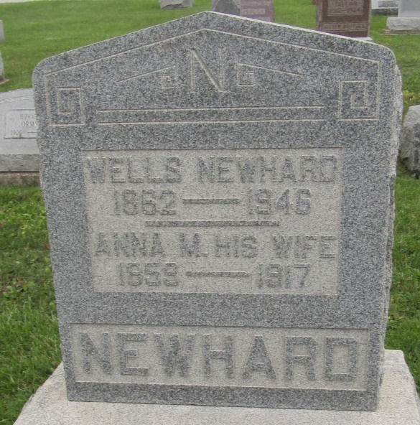

UNIONDALE WOMAN DEAD
Bluffton, Ind., March 1 – Mrs. Anna M. Newhard, wife of Wells Newhard, a prominent farmer, died at 3 o'clock this morning at her home north of Uniondale, from paralysis.
Surviving are the husband and three children, Jesse Newhard of Waycrosse, Ga., and Roswell and Morris S. Newhard, at home. The funeral will be held Thursday morning at 10:30 o'clock at the Prospect M. E. Church, with burial in the Prospect Cemetery.

Journal-Gazette, Allen County, Indiana
Friday, March 2, 1917

*****
Indiana, U.S., Death Certificates, 1899-2011
Name: Anna Newhard
[Anna Meeks]
Gender: Female
Race: White
Age: 51
Birth Date: 10 Mar 1859
Birth Place: Indiana
Death Date: 28 Feb 1917
Death Place: Uniondale, Wells, Indiana, USA
Father: George Meeks
Mother: Margaret Watson
Spouse: Wells Newhard
Informant: Wells Newhard; Uniondale, Indiana
Burial: March 2, 1917; Prospect Cemetery

