Henry Neuhauser
September 3, 1890 – January 10, 1969

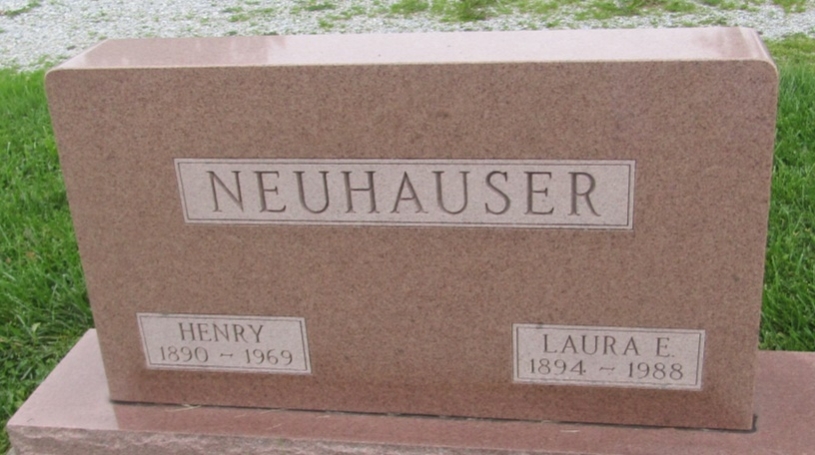

Henry Neuhauser, 78, of Markle, Route 1, died today at the Lutheran Hospital, Fort Wayne. He was born September 3, 1890 in Adams County, the son of Jacob and Rosanna Steiner Neuhauser. His marriage to Laura Crum, who survives, took place November 26, 1914 at the parsonage of Six Mile Church.
Surviving are a son, Max of Markle, Route 1; two daughters, Mrs. Waneta Goshorn of Uniondale and Mrs. Clark (Verdella) DeWalt of Markle, Route 1; two brothers, Edwin of Berne and Menno of Napoleon, Ohio; six grandchildren and a great grandchild.
Elzey Funeral Home in Ossian is in charge of arrangements with services to be held there Sunday; burial will be in Prospect Cemetery.

Bluffton News-Banner, Wells County, Indiana
January 10, 1969
*****

Indiana, U.S., Death Certificates, 1899-2011
Name: Henry Neuhauser
Gender: Male
Race: White
Age: 78
Marital status: Married
Birth Date: 3 Sep 1890
Birth Place: Indiana
Death Date: 10 Jan 1969
Death Place: Fort Wayne, Allen, Indiana, USA
Father: Jacob Neuhauser
Mother: Rosanna Steiner
Spouse: Laura
Informant: Mr. Max Neuhauser; son; Markle, Indiana
Burial: January 12, 1969; Prospect Cemetery; Wells County, Indiana

