Shirley A. (Hankins) Myers
November 4, 1939 – October 22, 2017

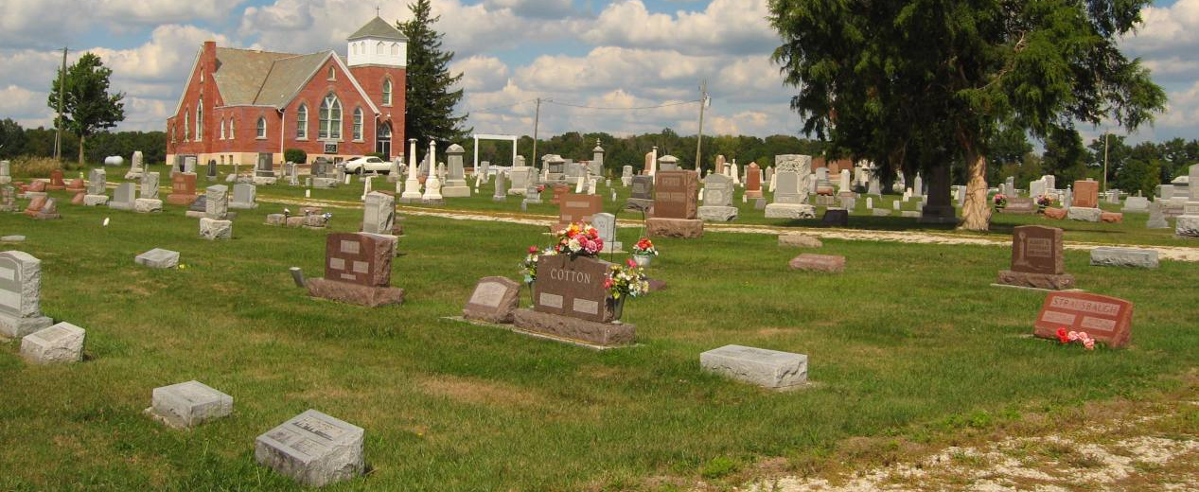
Photo by Tombstoner & Family

Shirley A. Myers, 77, of Bluffton, passed away Sunday, Oct. 22, 2017, at Visiting Nurse and Hospice Home. She was born Nov. 4, 1939, in Wells County to Howard and Ida L. Osborn Hankins.
She worked for Franklin Electric for many years, retiring in 2001. She attended River of Life Church. Shirley was an avid IU basketball fan and an Indianapolis Colts fan. She enjoyed spending time with her grandchildren.
Survivors include her children, Greg (Tina) Myers of Bluffton, Jeff (Ellen) Meyers of Hartford City, and David “DJ” Gephart of Bluffton; a sister, Carolyn Barnes of Bluffton; and nine grandchildren; and 12 great-grandchildren. She was preceded in death by two sons, Rick Myers in 2014 and Joey Myers in 1961; and a sister, Volise Myers in 2010.
A service will be held at 10 a.m. Thursday, Oct. 26, at Goodwin-Cale & Harnish Memorial Chapel with Pastor Wayne Ball officiating. Calling hours are from 2 to 7 p.m. Wednesday, Oct. 25, at the funeral home. Burial will be in Prospect Cemetery in Uniondale.
Memorials may be made to the Wells Community Boys and Girls Club.

Goodwin Funeral Homes, Wells County, Indiana
October 23, 2017

