Addaline (Goff) Ady-Mulrine
May 22, 1841- August 3, 1886

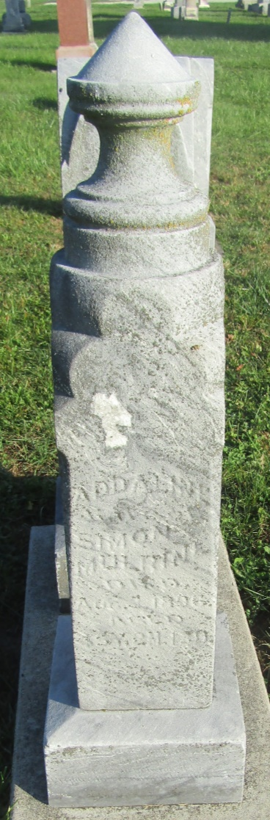

Indiana Marriages, 1811-2019
Name Simon Mulrine
Sex Male
Residence Place Bluffton, , Indiana
Birthplace , Wells, Indiana
Race White
Number of Previous Marriages 2
Father's Name Peter Mulrine
Mother's Name Nancy Pollock
Spouse's Name Adaline Goff Ady
Spouse's Sex Female
Spouse's Residence Place Bluffton, ,
Spouse's Birthplace , Turnbull, Ohio
Spouse's Race White
Spouse's Previous Marriage Number Second
Spouse's Father's Name John F Goff
Spouse's Mother's Name Marilla Lewis
Officiator's Name Thos L Winns
Event Place Wells, Indiana, United States
Marriage Place Bluffton, Indiana
Event Type Marriage Registration
Page 92
Number of Images 1
*****
Indiana Marriages, 1811-2019
Name Simon Molrine
Sex Male
Spouse's Name Adaline Ady
Spouse's Sex Female
Officiator's Name Thos L Wisner
Additional Person's Name A Oppenheim
Marriage Place Indiana
Marriage License Date 23 Jul 1892
Marriage License Place Wells, Indiana, United States
Page 11
Number of Images 1
Note A Oppenheim

