Mary L. (Wolfcale) Mullies
September 30, 1855 – February 15, 1892

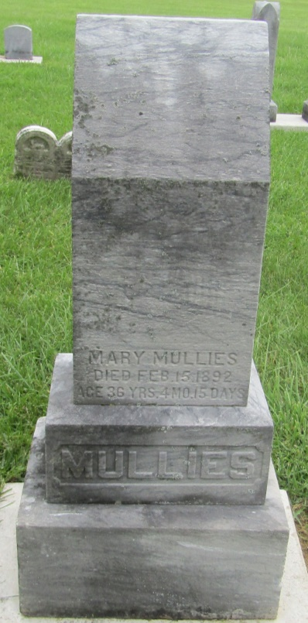

No further information found at this time

