Eliza Annie Mullies
1878 - 1898

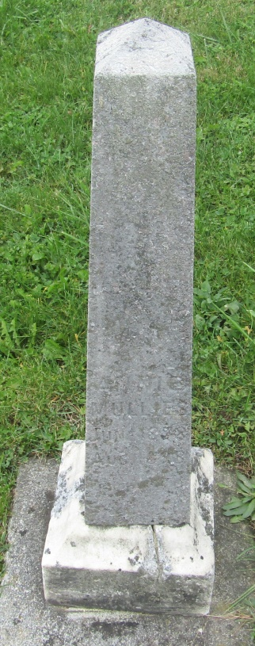

No further information found at this time

