Charles Milligan
February 20, 1852 – January 15, 1944

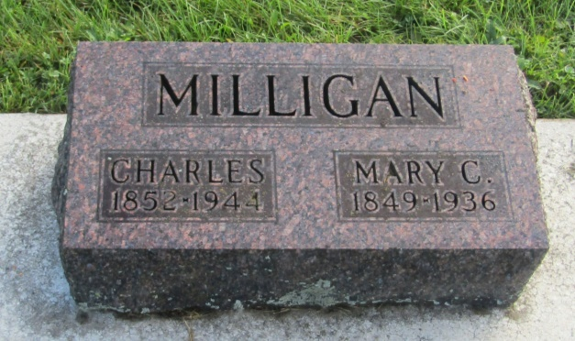

Charles Milligan
in the Indiana, U.S., Death Certificates, 1899-2011
Name: Charles Milligan
Gender: Male
Race: White
Age: 91
Marital status: Widowed
Birth Date: 20 Feb 1852
Birth Place: Fairfield Co Ohio
Death Date: 15 Jan 1944
Death Place: Allen, Indiana, USA
Father: Eli Milligan
Mother: Susan Hamilton
Spouse: Mary
Informant: Mrs. Alva Smith; Maples, Indiana
Burial: January 18, 1944; Prospect Cemetery; Wells County

