Lucy K. (Jones) Meyer
November 24, 1892 – January 11, 1990

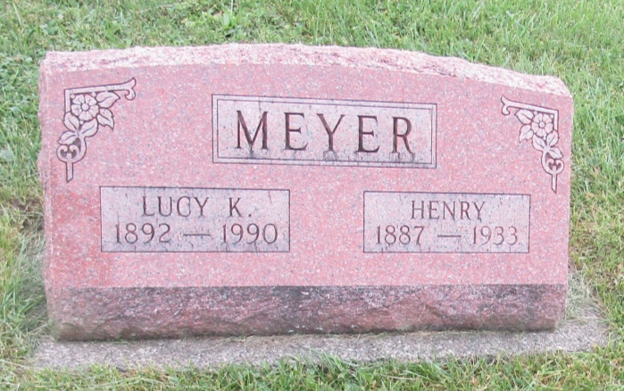

Lucy K Meyer
in the Indiana, U.S., Death Certificates, 1899-2011
Name: Lucy K Meyer
[Lucy K Jones]
Gender: Female
Race: White
Age: 97
Marital status: Widow
Birth Date: 24 Nov 1832 [sic]
Birth Place: Wells Co, In
Death Date: 11 Jan 1990
Death Place: Bluffton, Wells, Indiana, USA
Father: Joseph Jones
Mother: Ann Allen
Spouse: Henry Meyer
Informant: Ann Lydy; daughter; Bluffton, Indiana
Burial: January 15, 1990; Prospect Cemetery; Wells County, Indiana

*****
Indiana Marriages, 1811-2019
Name Henry Meyer
Residence Place , Wells, Indiana
Birth Date 06 Jan 1887
Birthplace , Jay, Indiana
Father's Name Adam Meyer
Mother's Name Caroline Saxman
Spouse's Name Lucy K Jones
Spouse's Residence Place , Wells, Indiana
Spouse's Birth Date 24 Nov 1892
Spouse's Birthplace , Wells, Indiana
Spouse's Father's Name Joseph Jones
Spouse's Mother's Name Martha A Allen
Marriage License Date 01 May 1913
Marriage License Place Wells, Indiana, United States
Page 163
Number of Images 1

