Hester M. (Dronberger) Meeks
June 11, 1856 – June 19, 1926

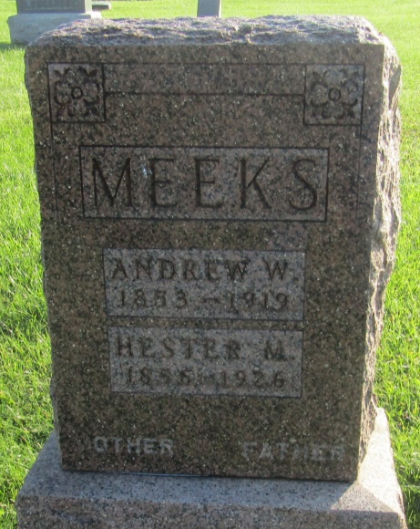

Hester M. Mecks
in the Indiana, U.S., Death Certificates, 1899-2011
Name: Hester M. Meeks
[Hester M. Droneburger]
Gender: Female
Race: White
Age: 70
Marital status: Widowed
Birth Date: 11 Jun 1856
Birth Place: Ohio
Death Date: 19 Jun 1926
Death Place: Fort Wayne, Allen, Indiana, USA
Father: Droneburger
Mother: Mary Wilcox
Spouse: Andrew W. Meeks
Informant: Mrs. Fred Tish?
Burial: June 21, 1926; Prospect Cemetery

