George D. McIntosh
March 13, 1898 – July 5, 1955

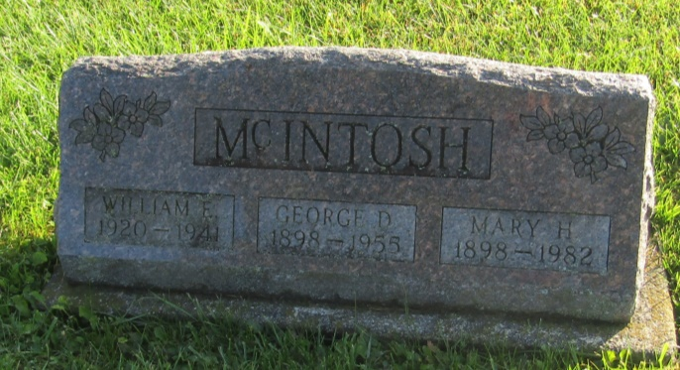

George D McIntonh
in the Indiana, U.S., Death Certificates, 1899-2011
Name: George D McIntosh
Gender: Male
Race: White
Age: 57
Marital status: Married
Birth Date: 13 Mar 1898
Birth Place: Howard County, Indiana
Death Date: 5 Jul 1955
Death Place: Bluffton, Wells, Indiana, USA
Father: Ira McIntosh
Mother: Brenton
Informant: Mrs. Vernard Jump; Ossian, Indiana
Burial: July 7, 1955; Prospect Cemetery; Ossian, Indiana

