Ira Kimball Longshore
September 22, 1859 – December 2, 1920

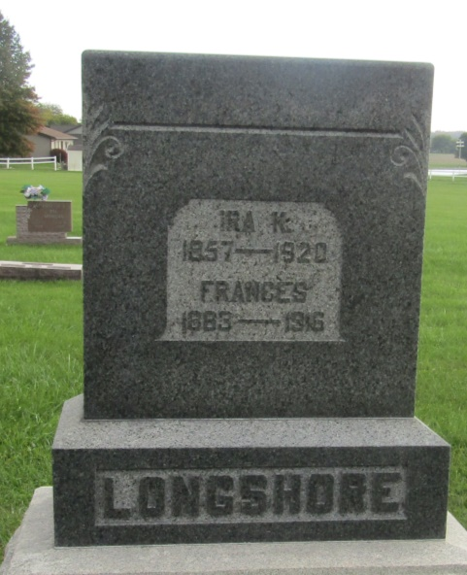

Ira K. Longshore
in the Indiana, U.S., Death Certificates, 1899-2011
Name: Ira K. Longshore
Gender: Male
Race: White
Age: 63
Marital status: Widowed
Birth Date: 22 Sep 1859
Birth Place: Ohio
Death Date: 2 Dec 1920
Death Place: Union, Wells, Indiana, USA
Father: Euclides Longshore
Mother: Sarah Scattergood
Spouse: Frances
Informant: Mrs. Frank Smith; Uniondale, Indiana
Burial: December 4, 1920; Prospect Cemetery

