David Longshore
September 1, 1846 – November 22, 1912

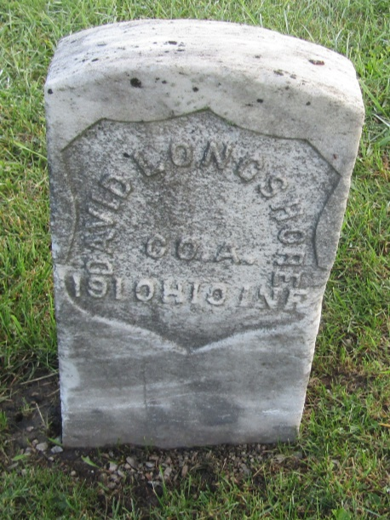

David Longshore
in the Indiana, U.S., Death Certificates, 1899-2011
Name: David Longshore
Gender: Male
Race: White
Age: 66
Marital status: Married
Birth Date: 1 Sep 1846
Birth Place: Ohio
Death Date: 22 Nov 1912
Death Place: Ft Wayne, Allen, Indiana, USA
Father: Euslytis
Mother: Sarah Skattergood
Spouse: Esther
Informant: J. D. Hite; Uniondale, Indiana
Burial: November 25, 1912; Uniondale, Wells County, Indiana

