Margaret J. Lipkey
March 19, 1853 – February 1, 1866

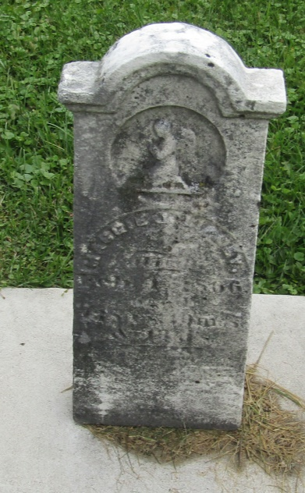

No further information found at this time

