Hattie A. Lipkey
May 30, 1885 – July 6, 1918

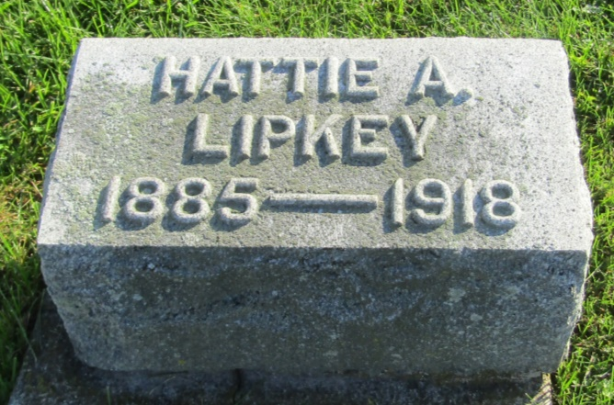

MISS LIPKEY KILLED
Her Automobile is Hit By C & E Train at Uniondale
(Special to the News) UNIONDALE, Ind., July 8 – Miss Hattie Lipkey, 35 years old, was instantly killed Saturday evening at 6:30 o'clock when her automobile was hit by a fast passenger train on the Erie Railroad at the Main Street crossing here.
Her father, James Lipkey, a well-known farmer living near Prospect, and her nephew, the son of Jess W. Lipkey, had alighted from the car but a few minutes before. They had come to Uniondale to spend the evening and to do some trading.
Apparently unaware of the approaching train, she drove directly in front of it and was hurled a distance of several yards. Her father saw the accident and was probably the first person to reach her side. She was dead, however, and her body was badly cut and bruised.
Miss Lipkey was a sister of Jess Lipkey, who is employed by the Eckart Packing Company at Fort Wayne, and a cousin of Cliff Lipkey, who was for some year’s managing editor of the Fort Wayne Journal-Gazette.
Up to eight years ago when her mother died, Miss Lipkey had been a teacher in the schools of Wells County. Following the death of her mother, however, she had given up teaching and was keeping house for her father.
Funeral services will be held Tuesday morning at 10 o'clock at the Prospect Church west of Ossian.

Fort Wayne Sentinel; Allen County, Indiana
Monday, July 8, 1918
*****

Indiana, U.S., Death Certificates, 1899-2011
Name: Hattie Lipkey
Race: White
Age: 33
Marital status: Single
Birth Date: 30 May 1885
Birth Place: Wells County Ind
Death Date: 6 Jul 1918; auto/train accident
Death Place: Union, Wells, Indiana, USA
Father: James M Lipkey
Mother: Martha J Longshore
Informant: James Lipkey; Uniondale, Indiana
Burial: July 9, 1918; Prospect Cemetery

