William L. Lepper
September 2, 1886 – April 11, 1895

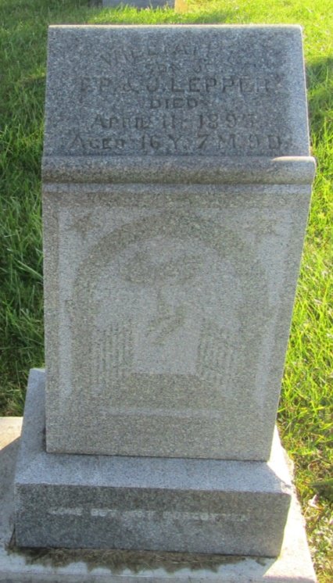

No further information found at this time

