William H. Lepper
May 8, 1849 – March 16, 1938

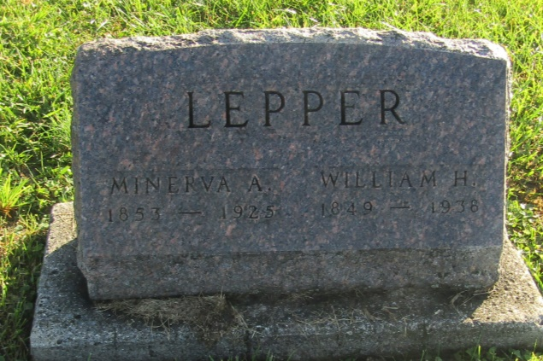

William A Lepper
in the Indiana, U.S., Death Certificates, 1899-2011
Name: William A Lepper
Gender: Male
Race: White
Age: 88
Marital status: Widowed
Birth Date: 8 May 1849
Birth Place: Wells, Co
Death Date: 16 Mar 1938
Death Place: Markle, Huntington, Indiana, USA
Father: John H Lepper
Mother: Phoebe Fairbanks
Informant: Mrs. Frank Zimmerlee
Burial: March 18, 1938; Prospect Cemetery

