John A. Lepper
August 22, 1808 – September 11, 1884

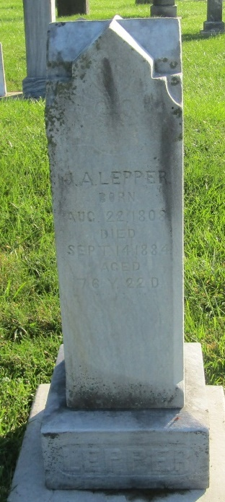

John A Lepper, born in Montgomery Co.,New York, to Jacob A. and Mary (Allen) Lepper. He lived in Trumbull Co., Ohio where 7 of his children were born. Sally (Jennings), Jacob, Olive (Covert), Mary (died as an infant), Thomas, James, and Lydia (Hoopengardner). He moved to Wells Co., Indiana in the late 1840's, and had 3 more children; William, John, and Mary (Goshorn). John married Louisa Sarah Fairbanks in Trumbull Co., Ohio in 1836; she passed in 1858 in Ossian, Wells Co., Indiana. John's second wife was Martha (DeMoss) Covert in 1860; she was the widow of Sheriff Isaac Covert.
John spent his life in Manufactures & Trade in Ohio, and a farmer in Indiana raising his large family. He helped in foundation of the Prospect Methodist Church in Union Township, Indiana and held the services in his home in the late 1840's until the church was built in the 1860's. He is buried in the Prospect Cemetery, Wells County, Indiana.

Unknown source
*****
John A Lepper from tree Hastings Family Tree
Birth 22 Aug 1808 Montgomery, Orange, New York, USA
Marriage 9 Aug 1860 Wells, Indiana, USA
Residence 1880 Wells, Indiana, USA
Death 11 Sep 1884 Ossian, Wells, Indiana, USA
Father Jacob Lepper (1789-1816)
Mother Mary Allen (1791-1867)
Spouse Martha Demoss (1815-1902)

