Charles Hamilton Krewson
February 3, 1854 – March 7, 1882

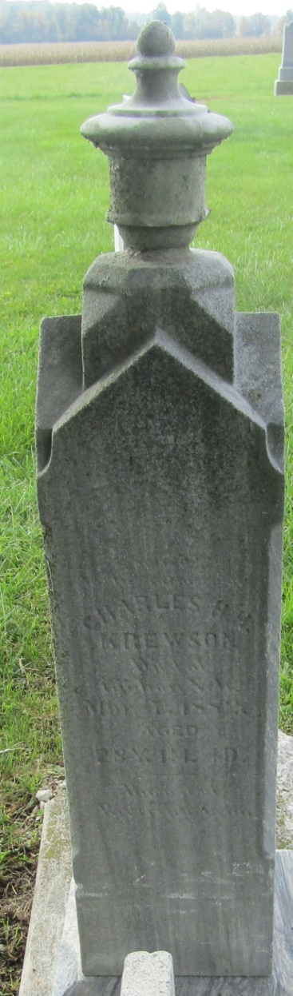

Mr. Chas Krewson, who was last summer employed by H. Mathies as clerk in his office of Register of Deeds, died at the residence of his brother at Gibbon, Buffalo County, Nebraska last week Tuesday, from consumption.
Mr. Krewson was an excellent young man, and had hosts of friends, wherever known, who will regret to learn of his death.

Newton Kansan; Newton, Kansas
Thursday, March 16, 1882
*****
Charles Hamilton Krewson from tree Axtell Family Tree
Birth 3 Feb 1854 Wells, Indiana, USA
Residence 1880 Newton, Harvey, Kansas, USA
Death 7 Mar 1882 Gibbon, Buffalo, Nebraska, USA
Father Simon Krewson (1815-1863)
Mother Margaret Gilkerson (1814-1896)

