William Jesse Kitchen
July 3, 1887 – May 11, 1962

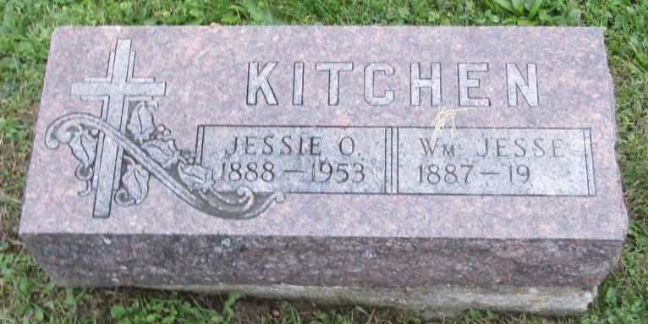

Indiana, U.S., Marriages, 1810-2001

Name: William Jesse Kitchen
Gender: Male
Race: White
Age: 20
Event Type: Marriage Registration (Marriage)
Birth Date: 3 Jul 1887
Birth Place: Wells, Indiana
Marriage Date: 1 Jul 1908
Marriage Place: Indiana, United States
Residence Place: Wells, Indiana
Father: James C Kitchen
Mother: Emma Smith
Spouse: Jessie Olive High
Officiator: Samuel D High
Page: 18
*****

California, U.S., Death Index, 1940-1997

Name: William J Kitchen
Social Security #: 304129137
Gender: Male
Birth Date: 3 Jul 1887
Birth Place: Indiana
Death Date: 11 May 1962
Death Place: Los Angeles
Mother's Maiden Name: Smith

