Jessie Olive (High) Kitchen
February 13, 1888 – November 2, 1953

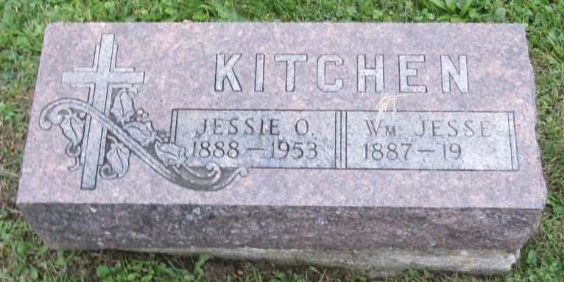

Jessie Clive Kitchen
in the Indiana, U.S., Death Certificates, 1899-2011

Name: Jessie Olive Kitchen
[Jessie Olive High]
Gender: Female
Race: White
Age: 65
Marital status: Married
Birth Date: 13 Feb 1888
Birth Place: Indiana
Death Date: 2 Nov 1953
Death Place: Rural, Allen, Indiana, USA
Father: Raoul (?) High
Mother: Emmy Beatty
Informant: William Kitchen; husband; Fort Wayne, Indiana
Burial: November 4, 1953; Prospect Cemetery; Adams County, Indiana

